Aha World of Taste

Software Requirements Specification

1.0

May 13th, 2023

1. Pydi Venkata Satya Ramesh Adapa - Project Manager

2. Jyothsna Pamarthi - Team Lead

3. Anjali Bhogireddy - Full Stack Developer

4. Sushmitha Yelmakonda - Tester

5. Jagadeesh Ponnam - Scrum Master

6. Ravi Chandra Yalla - Full Stack Developer

Submitted in partial fulfillment

Of the requirements of

CSIS 44-691 Graduate Directed Project 1

# Revision History

|  |  |  |  |
| --- | --- | --- | --- |
| **Date** | **Description** | **Author** | **Comments** |
| <date> | <Version 1> | <Your Name> | <First Revision> |
|  |  |  |  |
|  |  |  |  |
|  |  |  |  |

# Document Approval

The following Software Requirements Specification has been accepted and approved by the following:

|  |  |  |  |
| --- | --- | --- | --- |
| **Signature** | **Printed Name** | **Title** | **Date** |
|  |  |  |  |
|  |  |  |  |
|  |  |  |  |

**Table of Contents**

**Table of Contents Page Number**

1. Introduction
   1. Purpose
   2. Scope
   3. Definitions, Acronyms, and Abbreviations
   4. References
   5. Overview
2. General Description
   1. Product Perspective
   2. Product Functions
   3. User Characteristics
   4. General Constraints
   5. Assumptions and Dependencies
3. Specific Requirements
   1. External Interface Requirements
      1. User Interfaces
      2. Hardware Interfaces
      3. Software Interfaces
      4. Communications Interface
   2. Functional Requirements
   3. Use Cases
   4. Class/Objects
   5. Non-Functional Requirements

3.5.1. Performance

3.5.2. Reliability

* + 1. Availability
    2. Security
    3. Portability
  1. Inverse Requirements
  2. Design Constraints
  3. Logical Database Requirements
  4. Other Requirements
  5. Prototypes (for complete project)
  6. Use Case Diagrams

1. Design

4.1. ER diagram

4.2. GUI

1. Analysis Models

5.1. Data Flow Diagram

5.2. Sequence Diagram

1. **Introduction**
   1. **Purpose**

Nowadays restaurants are facing challenges in managing its operations and providing a seamless customer experience. To improve this, we will be creating a web application that allows customers to view the menu online, order for pickup or delivery, make reservations, and communicate through online chat. The goal is to streamline operations, reduce wait times, and increase customer satisfaction, leading to more sales.

* 1. **Scope**

The restaurant intends to develop a website that will run on a server and provide registered customers with the ability to browse and order food items of their choice. Additionally, customers will be able to monitor the delivery of their orders and book tables at specific times, subject to availability. Restaurant Owner will be able to use the website to set up tables for customers, remotely manage table operations, confirm, and transmit orders to the food preparation crew, and finalize customers' bills. The website will also allow delivery personnel to update delivery statuses and confirm when orders have been successfully delivered to customers. The website will feature strict accountability and tracking mechanisms, as well as support for supervisor actions to account for all transactions.

* 1. **Definitions, Acronyms, and Abbreviations**

1. **Live Chat:** Live chat is a method of online communication that enables real-time conversations between individuals or businesses and their customers or website visitors.
2. **Admin:** Admin is the term used to describe the restaurant management or the one in charge of managing the day-to-day operations of the company.
3. **Customer:** Customer is the person simply the user of this application who can view and order the available food items.
4. **Menu:** A menu is webpage that displays a list of food and drink items that are available for customers to order.
5. **Web Application:** Web applications are software programs that can only be utilized online and accessible by using a web browser.

* 1. **References**

The approaches taken by successful online food ordering and table booking applications.

* 1. **Overview**

The Restaurant web application is useful for restaurant owners who want to streamline their online ordering system and increase their online presence. The application offers several features that make it simple for businesses to manage their online ordering process. A personalized menu that can be easily updated, online chat, the ability to take online orders directly from a website and the ability to manage customer data including contact information and order history are some of these features. The application is designed to be user-friendly with a simple interface that makes it easy for users to navigate and complete tasks. By using this web application, restaurants may improve customer satisfaction, increase efficiency, and save time. Overall, the Restaurant web application is used to streamline their business operations and enhance their online ordering system.

1. **General Description**
   1. **Product Perspective**

The restaurant application is a standalone application, accessible through a web browser that would highly focus on giving consumers a convenient and user-friendly platform to browse menu items, place orders, and make payments. This application also provides the restaurant owners and managers with tools to manage inventory, track sales, and analyze customer data.

* 1. **Product Functions**

Following are the functions offered by this restaurant applications:

1. **Live chat:** Live chat functionality allows users to ask questions, get assistance with problems, and receive advice on products or services through a chat interface.
2. **Menu Browsing:** Allows users to view the complete menu of restaurant based on their type.
3. **Search functionality:** Search functionality allows users to search for specific content or information about food available within the website.
4. **Like and review system:** Customers can share their views and ideas about their experience using the like and review feature in restaurant applications. It helps in decision-making for other customers and allows restaurants to better understand customer behavior.
5. **Table reservation system:** Table reservation system is a feature that enables customers to reserve tables in advance at a restaurant and it helps restaurants to manage their table occupancy and staffing needs.
6. **Food ordering system:** Customers can place food orders directly from their smartphones or computers with the help of a food ordering system for delivery or pickup. Typically, it involves a series of steps called menu browsing, order customization, adding to cart and checkout.
7. **Food item management system for restaurant workers:** Restaurant owner or authorized worker can add food items to the menu with the help of GUI rather than updating data in backend.
   1. **User Characteristics**
   2. **Restaurant owners and employees:** The primary users of a restaurant management system are restaurant employees such as waiters, chefs, managers, and hosts. They require an easy-to-use, efficient, and accurate system for managing restaurant operations such as collecting orders, maintaining menu items, managing reservations, and processing payments.
   3. **Customers:** Customers may engage with certain components of it, such as making online bookings (reservations) or placing online orders. The system should be easy to use and offer clients consistent experience.
   4. **IT professionals:** IT professionals may be responsible for establishing, maintaining, and troubleshooting the restaurant management system.
   5. **General Constraints**

There are many constraints while developing a web application for a restaurant. Firstly, the application must be accessible via the internet, which requires customers to have internet access and a web browser. Additionally, the application must be compatible with a variety of devices and operating systems to ensure that it can be accessed by the largest possible audience. Security is also a crucial constraint, as sensitive customer information, such as payment details, will be transmitted through the application. The application must also be scalable and able to handle high traffic during peak hours without crashing or slowing down. Finally, the application must comply with any relevant legal and regulatory requirements, such as data protection laws and accessibility guidelines.

* 1. **Assumptions and Dependencies**

The website's effectiveness relies on customers having an internet connection and a web browser, as well as restaurant workers having appropriate hardware and software to handle food items, process orders, and manage reservations.

1. **Specific Requirements**
   1. **External Interface Requirements** 
      1. **User Interfaces**
2. The website will have a modern UI/UX design.
3. The website will be mobile-responsive.
4. The website will have a menu with food items and prices.
5. The website will have a search feature to allow customers to find specific food items.
6. The website will have a live chat feature for customer support.
   * 1. **Hardware Interfaces**

This website will require a computer or mobile device with a web browser and an internet connection.

* + 1. **Software Interfaces**

The website will be developed using modern web technologies, including HTML, CSS, and JavaScript.

* + 1. **Communications Interface**

The website will require an internet connection for real-time communication between customers and restaurant workers through the live chat feature.

* 1. **Functional Requirements:** The website will have the following functional requirements:

1. Customers should be able to browse the menu.
2. Customers should be able to search for menu items.
3. Customers should be able to place orders for pickup or delivery.
4. Customers should be able to make reservations for tables.
5. Customers should be able to leave reviews and ratings for menu items.
6. Customers should be able to like menu items.
7. Restaurant workers should be able to manage food items.
8. Restaurant workers should be able to process orders.
9. Restaurant workers should be able to manage reservations.
   1. **Use Cases:** The following use cases have been identified for the website
10. Customer browses the menu.
11. Customer searches for menu items.
12. Customers place an order for pickup or delivery.
13. Customer makes a reservation for a table.
14. Customer leaves a review and rating for a menu item.
15. Customers like a menu item.
16. Restaurant workers add a new food item to the menu.
17. Restaurant workers edit an existing food item on the menu.
18. Restaurant worker deletes a food item from the menu.
19. Restaurant worker receives an order from a customer.
20. Restaurant worker processes an order from a customer.
21. Restaurant worker manages reservations.
    1. **Class/Objects:** The website will have the following classes/objects.
22. Menu item
23. Customer Order
24. Reservation
25. Review
26. Like
27. Restaurant worker
    1. **Non-Functional Requirements**
       * 1. **Performance**:
28. The website should be designed for optimal performance, with fast loading times and minimal lag.
29. The website should be able to handle a high volume of traffic and requests.
    * + 1. **Reliability:**
30. The website should always be reliable and available for use.
31. The website should be designed to minimize downtime and ensure data is not lost.
    * + 1. **Availability**:

The website should always be available to users, with minimal downtime for maintenance and updates.

* + - 1. **Security**:

1. The website should be secure, with measures in place to protect user data and prevent unauthorized access.
2. The website should use encryption to protect sensitive data.
   * + 1. **Portability**:

The website should be portable, able to run on a range of devices and web browsers.

* 1. **Inverse Requirements**

The website should not have any inverse requirements, meaning that the website should not cause any negative impacts on users or restaurant workers.

* 1. **Design Constraints**

1. The website should be designed with a responsive layout that is optimized for a range of devices, including desktop computers, laptops, tablets, and smartphones.
2. The website should use modern web design principles to ensure an intuitive and user-friendly experience.
   1. **Logical Database Requirements**

The website will require a database to store menu items, customer information, orders, reservations, reviews, and likes. The database should be designed for optimal performance and reliability.

* 1. **Other Requirements**

1. The website should be designed to meet accessibility standards, ensuring that all users can access and use the website regardless of their disabilities.
2. The website should also be designed to meet any local laws and regulations governing online restaurant websites.

## Prototypes (for complete project)

**Home page**

Home page contains some features like:

1. Restaurant name and logo.
2. Navigation menu with links to different sections of the website (e.g., Menu, Reservations, About Us, Contact).

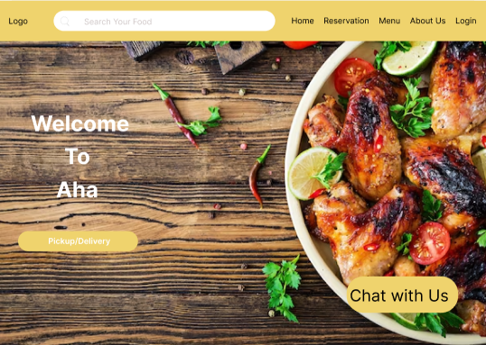

1. Navigation button to reserve a table.

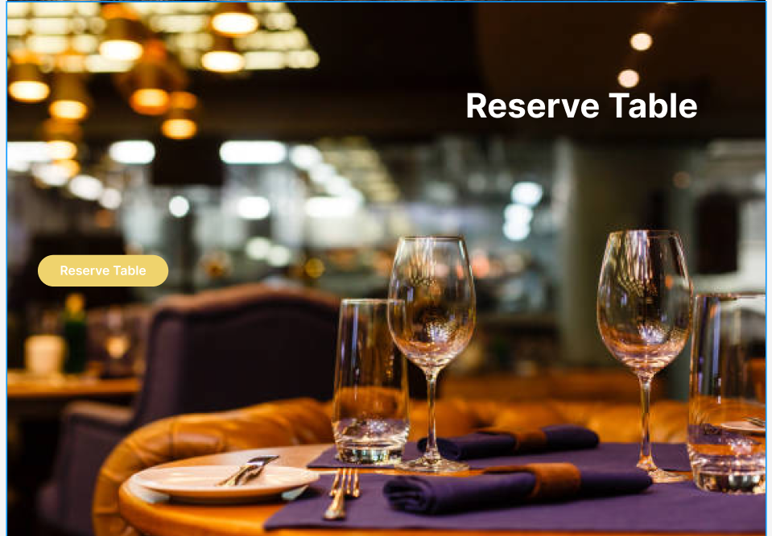

1. Displays a menu and signature dishes. 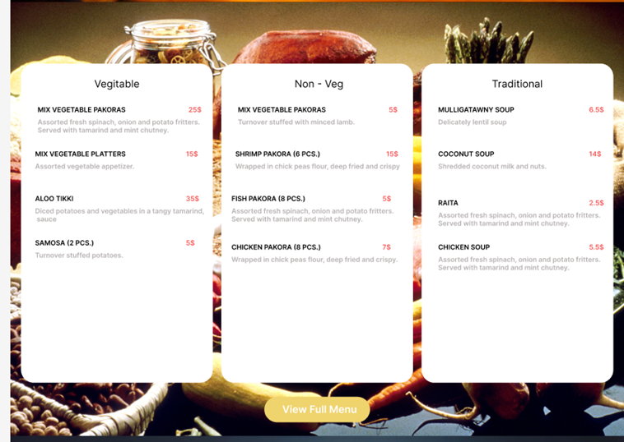
2. A brief introduction to the restaurant and its unique features along with the contact details to order online.

**Reservation Page**

Reservation page contains features like:

1. Reservation page with fields for date, time, number of guests, and special requests. availability calendar to choose the desired date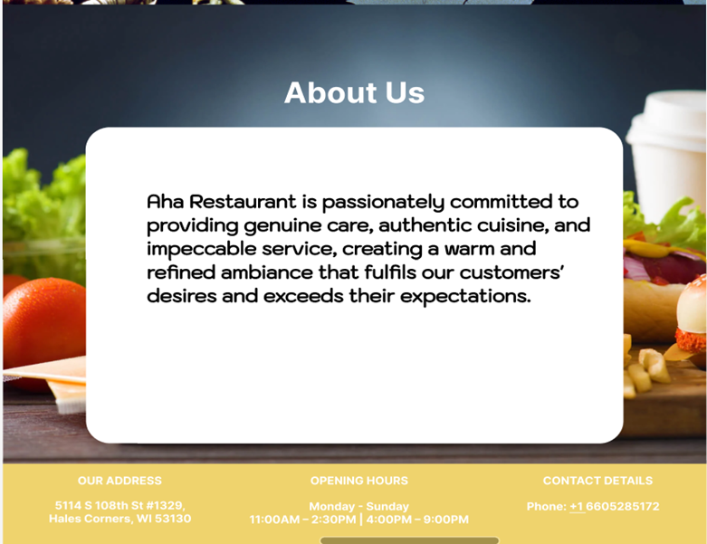.

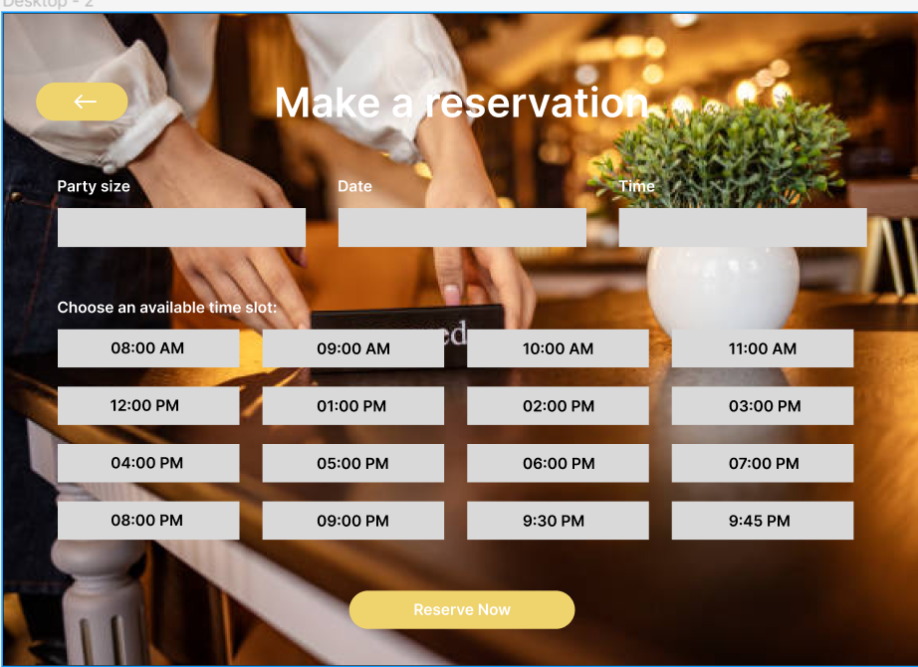

1. Reservation form to enter the customer details like first name, last name, phone number and email address.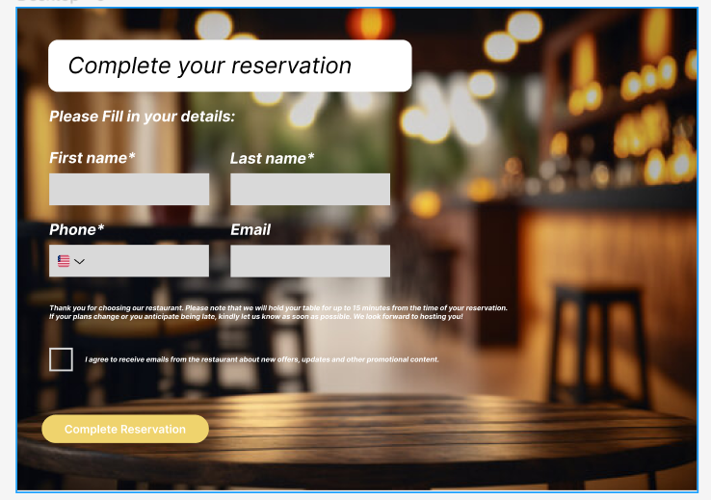
2. Confirmation message after successful reservation.

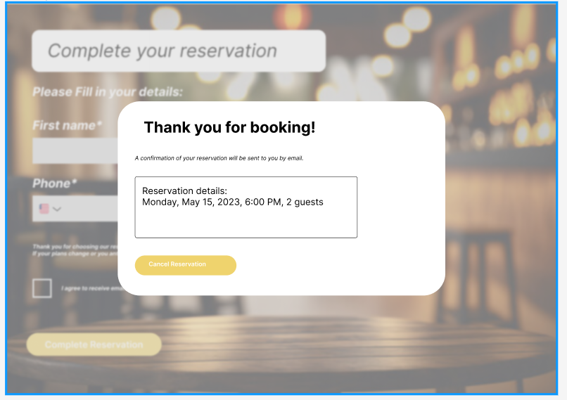

**Menu page**

Features of menu page are as follows :

1. Categorized menu items with images, descriptions, and prices.
2. Search functionality to quickly find specific dishes.
3. Specials or recommended dishes highlighted separately.
4. Dietary or allergy information for each item if applicable.

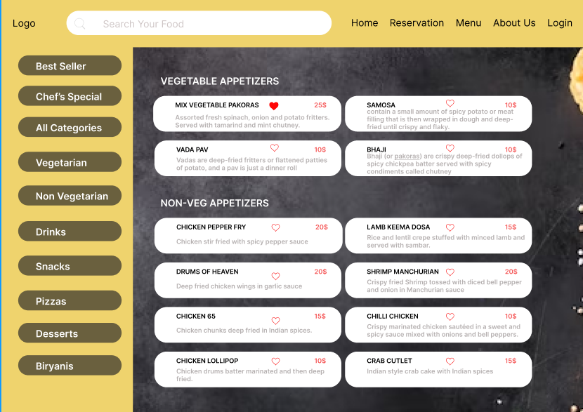

1. Displays an item details and “Add to cart “ button by clicking on an item.

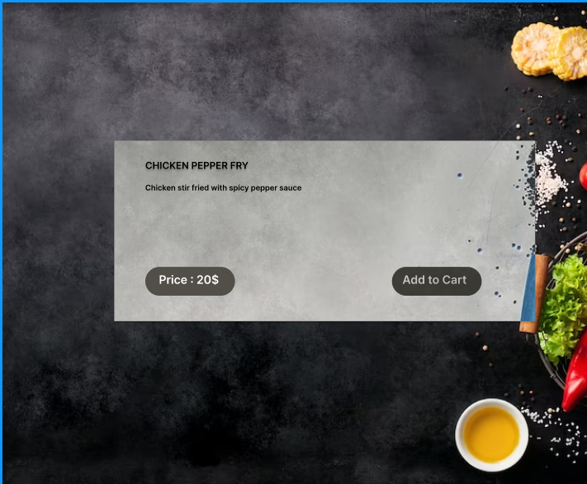

1. On selecting “Add to cart” button alerts the customer to login with a login page. Login with valid email address and password

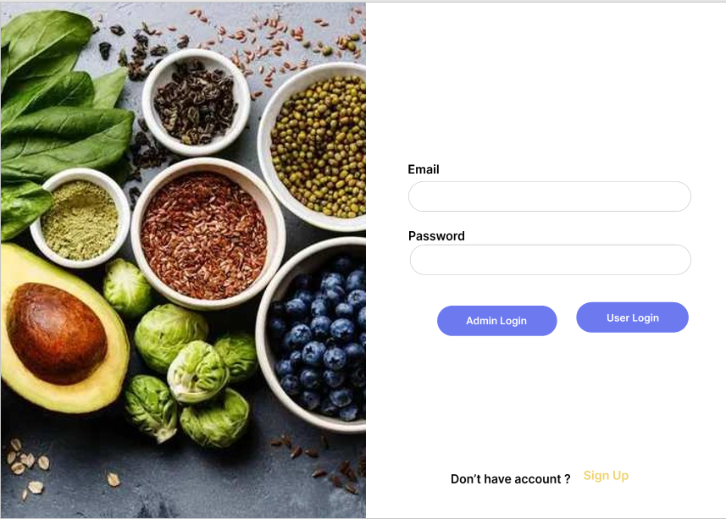

Here in Login page we have Admin Login Option where Restaurant owner or worker can login and manage the menu, orders and reservations.

1. If the customer is a first-time user, select signup.Fill the form by entering customer details like username, email address and password

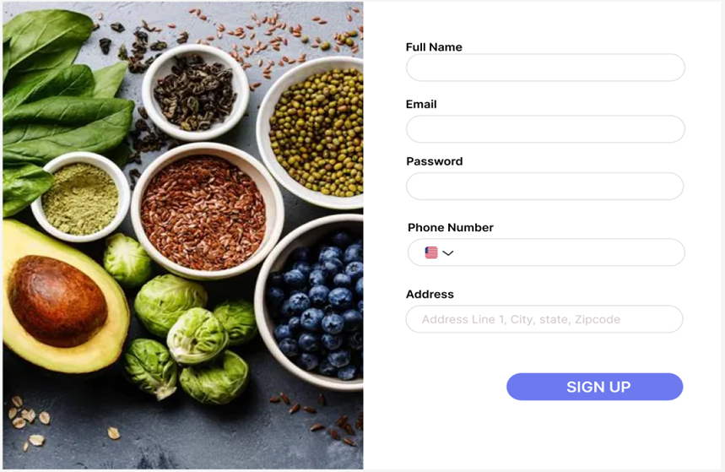

1. After a successful login, it will redirect to the summary page. The summary page contains details like a list of ordered items and modes of delivery like:
2. Pickup

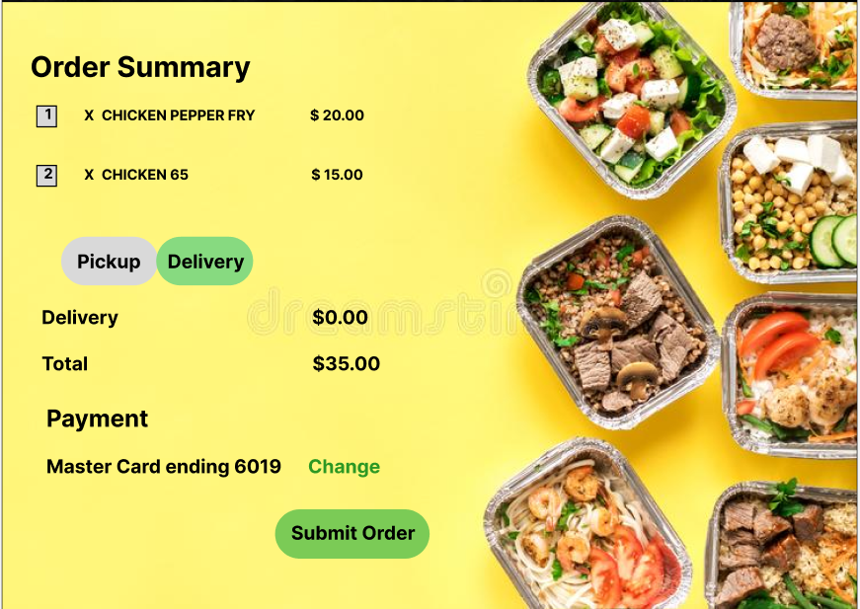

1. Delivery

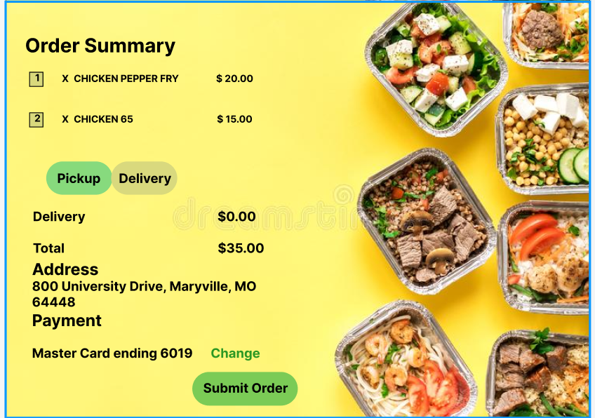

1. Displays order confirmation with a “Order successful” message, by clicking on the “Submit order” button.
2. Displays order status and back to menu buttons.

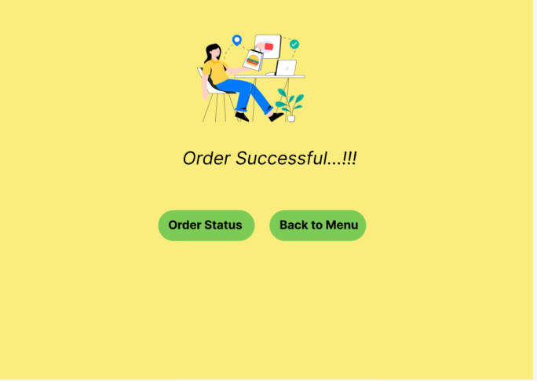

1. Order status button redirects to the order status page.

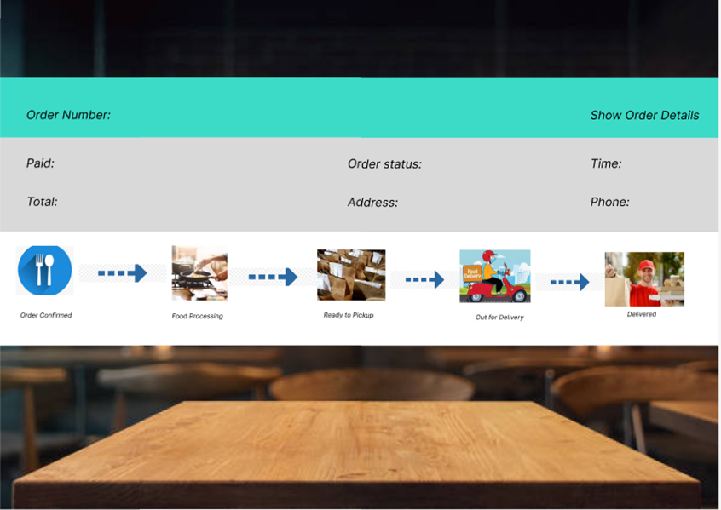

1. Admin Home Page Where admin functions are listed.

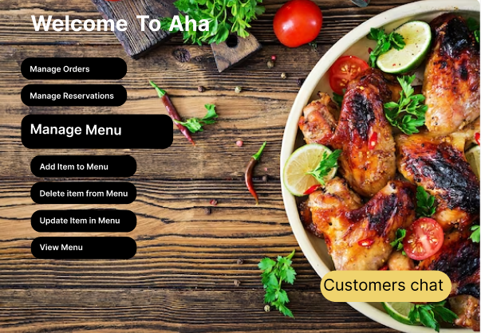

1. In this Page admin can add any item to the menu. If the Item_ID is not mentioned ID will be generated automatically in the database.

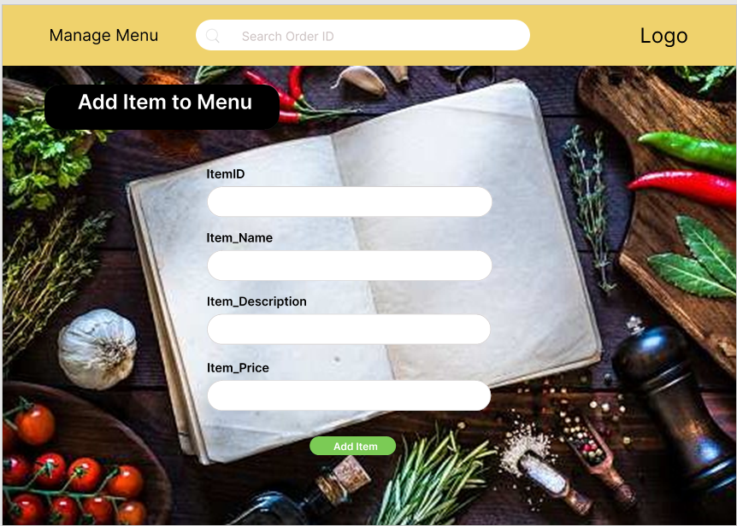

1. In this Page admin can delete any item to the menu. Initially the admin searches for the item with id or name, then list of items will appear on the screen similar to search function in menu and then he enters the same item_Id and the item with that Item_Id will be deleted.

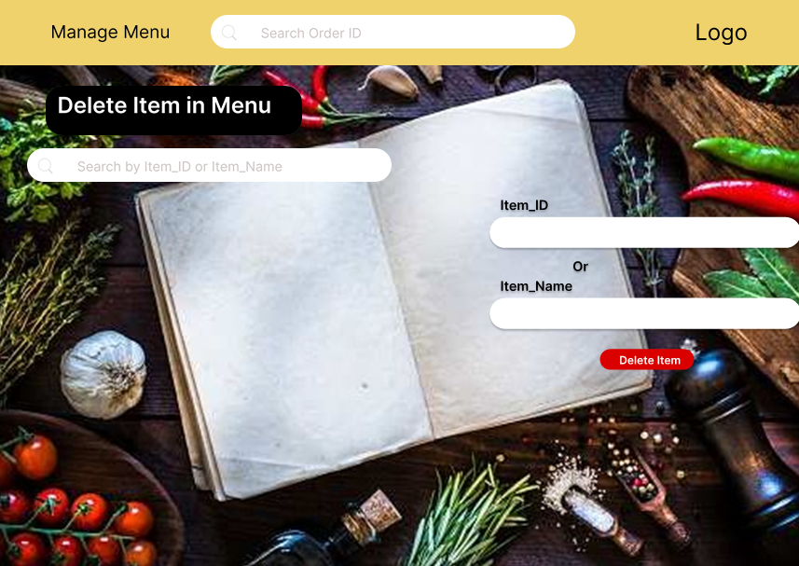

1. In this Page admin can update any item to the menu. Initially the admin searches for the item with id or name, then list of items will appear on the screen like search function in menu and then he enters the same item_Id and respective details he want to update then the item with that Item_Id will be updated.

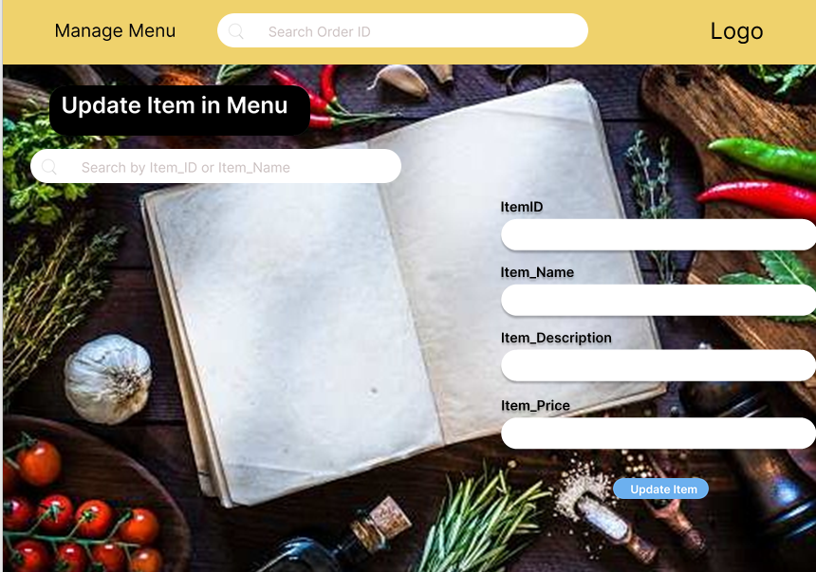

1. View of Complete Menu with Item_Id, Item_Description, Item_Name, Item_Price

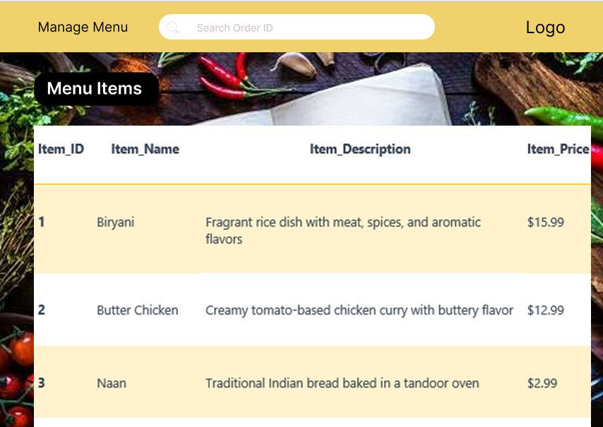

1. Managing Orders Page: Here the admin can view all the orders as a list and then he can search for specific orders using search box with order ID. Admin will update the status of order like accepting order and then order will be prepared once preparation is done he will click “order prepared” button such that user gets order update in his tracking page and this updating will continue until the order is delivered. These orders are for delivery option if the user selects pickup “Out for Delivery ” and “Delivered” buttons will be disabled.

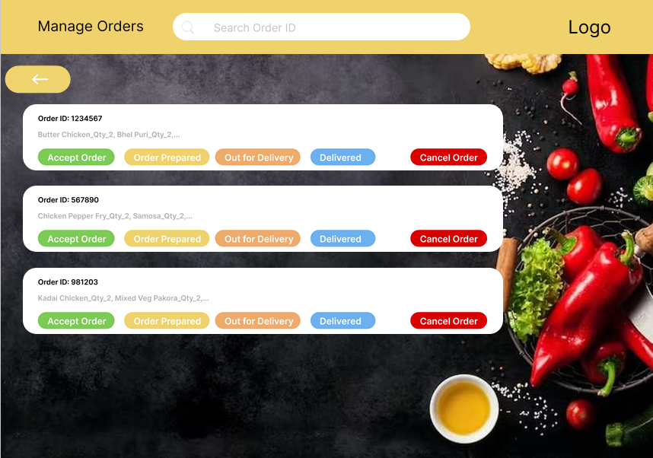

1. Managing Reservations Page: Here the admin confirms the reservation by seeing available tables for that time and confirms reservation. If there is no table available notification will be sent to the customer as space is unavailable.

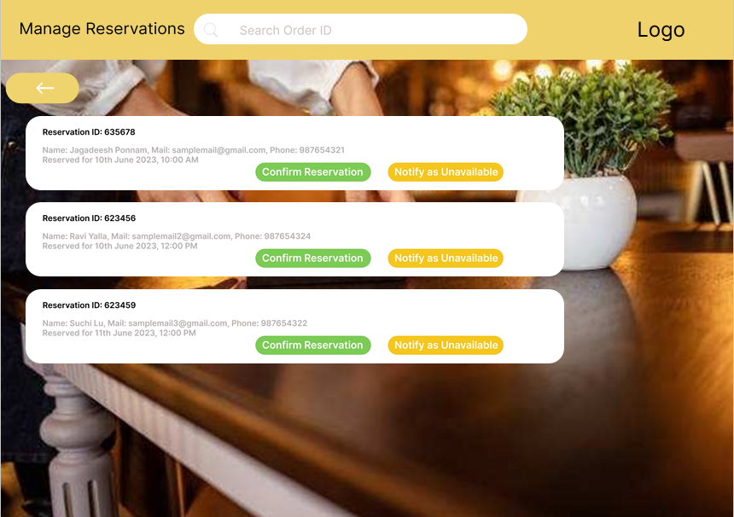

1. Live Chat: Using live chat users interacts with admin.

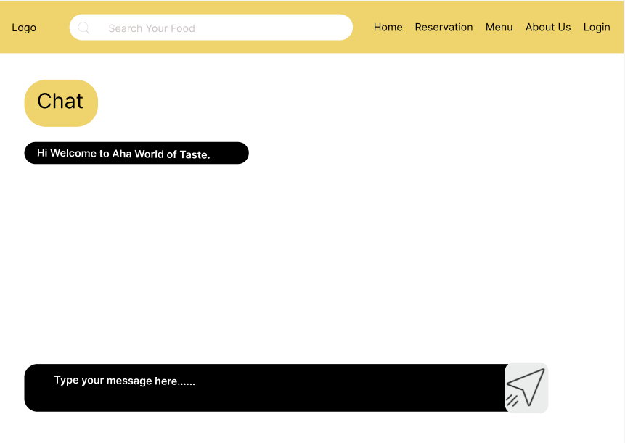

* 1. **Use Case Diagrams**

The following use cases have been identified for the website.

a) Customer browses the menu.

**Use Case: Menu Browsing**

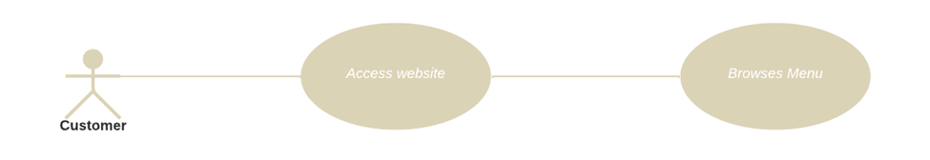

**Brief description:**

Customers have access to browse the entire menu provided by the restaurant.

**Step-by-Step description:**  
                   To begin this use case, the customer must be online and should be connected to the    
                   restaurant's website to access online services.   
  
                   1. The Customer wishes to use their mobile device to go through a restaurant's menu  
                       Options.  
                   2. Customers launch the restaurant website on their phone.  
                   3. The website would display the home page containing the restaurant’s menu.  
                   4. The customer browse the menu part by scrolling vertically upwards    
                       and downwards.   
                   5. To view its contents, they can tap on a certain food item of their choice.

b) Customer searches for menu items.

**Use Case: Searches Menu Item**

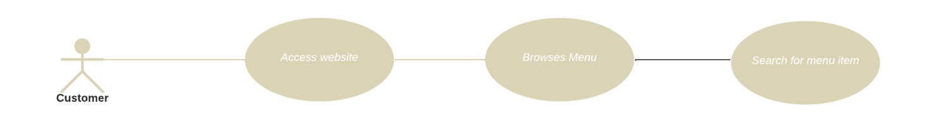

**Description**

Customers have access to a website to browse the entire menu provided by the restaurant and search for the menu item.

**Initial Step-by-step description**

To begin this use case, the customer must be online and should be connected to the

restaurant's website to access online services.

1. The Customer wishes to use their mobile device to go through a restaurant's menu

Options.

2. Customers launch the restaurant website on their phone.

3. The website would display the home page containing the restaurant’s menu.

4. The customer browse the menu part by scrolling vertically upwards

and downwards.

5. To view its contents, they can tap on a certain food item of their choice.

6. Customers can search the food item directly or with the help of menu filters.

1. Customers place an order for pickup or delivery.

**Use Case: Place an order for pickup or delivery.**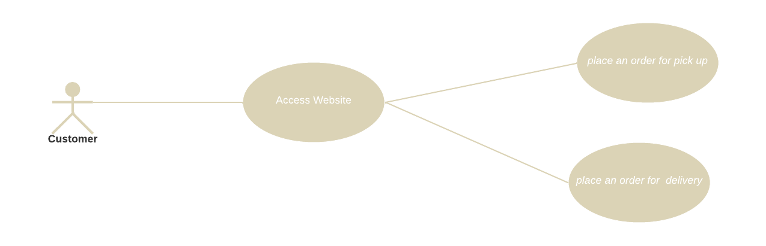

**Brief description:**

Customer can select his/her desired food items from the restaurant menu and place an

order for pickup or delivery.

**Step-by-Step description:**

To begin this use case, the customer must be online and should be connected to the

restaurant's website to access online services.

1. Customer should have an account to place an order and then
2. The customer can go through the restaurant’s menu and select the food items of their choice.
3. Customers can add all the selected food items to the cart.
4. The customer can place an order for pick up or delivery.
5. The website retains the information in the database.
6. The website notifies the admin that an order has been placed.
7. The Admin inspects the order and confirms the order.
8. The website displays a message to the customer like “your order is successfully placed”.
9. Customer makes a reservation for a table.

**Use Case: Table Reservation**

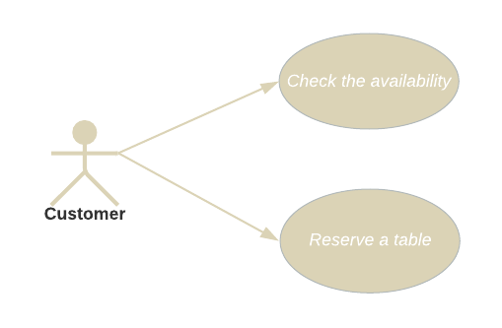

**Figure: Table Reservation.**

**Description:**

The customer makes use of the website to reserve a table.

**Initial step-by-step description:**

To initiate this use case, the Customer must be connected to the internet, logged in on the restaurant's webpage.

1. The customer selects the “Table Reservation” button.

2. The website returns the webpage containing the available tables information.

3. The customer selects an available table at the restaurant at a specified time.

4. The website displays a popup to confirm the Customer’s selection.

5. The customer clicks on the “Confirm” button.

6. The website retains the information in the database.

7. The website displays a message to the Customer for a successful table reservation.

8. The website notifies the admin that a table has been reserved.

9. The website updates the available tables information.

1. Customer leaves a review and rating for a menu item.

**Use Case: Review and Rating**

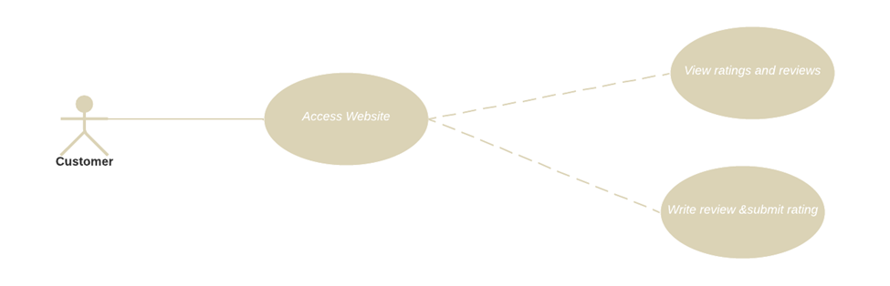

**Figure: Review and rating.**

**Brief description:**

Customers can share their opinions and experiences with the restaurant so that other

customers can make better decisions.

**Step-by-Step description:**

                  To begin this use case, the customer must be online and should be connected to the

restaurant's website to access online services.

                  1. Customers launch the restaurant website on their phone.

2. Then the customer navigates to the home page containing the restaurant’s details section.

                  3. The customer can view the average ratings and feedback of restaurant provided

                       by other users in the restaurant info section.

                  4. The customer can read these reviews to know about other user's experiences, the

                      food quality and service, the ambiance, and any significant features or drawbacks

                      of the restaurant.

                  5. If they wish, customers can share their opinion by tapping "write a review" option.

                  6. To express their overall satisfaction level, the customer is asked to provide

                       provide numerical ratings (such as excellent, good, average, or poor).

                  7. After completing the review, the customer submits it by tapping the submit option.

                 8. The user's review appears to other users on the restaurant's page.

1. Customers like a menu item.

**Use Case: Likes menu item**

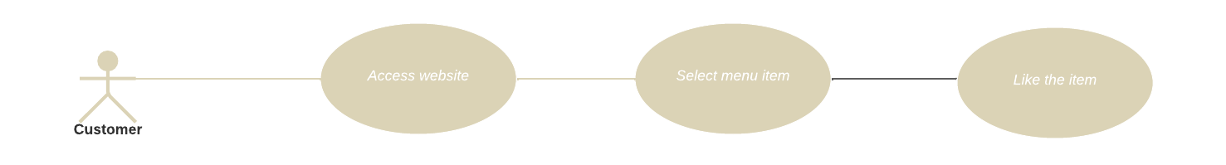

**Description**

Customers have to access a website to browse the menu and select an item as of his own choice and like the menu item.

**Initial Step-by-step description**

1.Go to the restaurant's website.

2.Find the menu section.

3.Look for the item you want to like.

4.Click the like button or icon associated with that item.

5.If prompted, log in or create an account.

6.Once logged in, the website will register your likes.

7.Repeat for other items you want to like.

1. Restaurant workers add a new food item to the menu.

**Use Case : Adding food item**

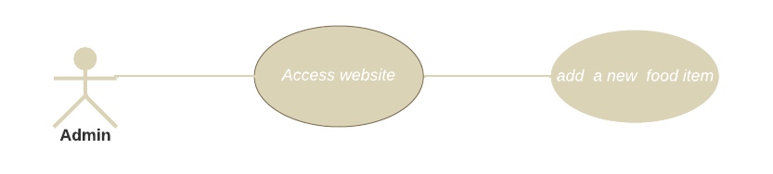

**Brief description:**

The admin can add a new food item to the menu

**Step-by-Step description:**

To begin this use case, the admin must be online and should be connected to the

restaurant's website to make changes in the application menu.

1. The admin accesses the website’s database.
2. The admin can add the desired food item they want to add to the menu.
3. The admin updates the database by saving the changes made to the menu.
4. The food item has been successfully added to the restaurant website menu.
5. The website is updated according to the updates in the database.
6. Restaurant workers edit an existing food item on the menu.

**Use Case: Restaurant workers edit an existing food item on the menu.**

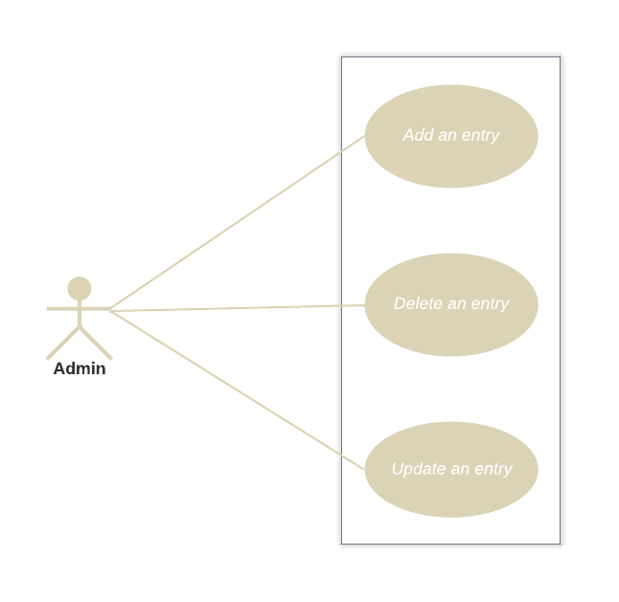

**Figure 8: Update an entry (Admin Access).**

**Brief Description:**

The admin chooses to update an entry of any existing item in the website’s database.

**Initial step-by-step description:**

To initiate this use case, the Customer must be connected to the internet, logged in on the restaurant's webpage.

1. The Admin accesses the website’s database.

2. The Admin adds a new entry or updates an existing entry.

3. The Admin saves the changes made.

4. The website is updated according to the updates in the database.

1. Restaurant worker deletes a food item from the menu.

**Use Case: Deleting item.**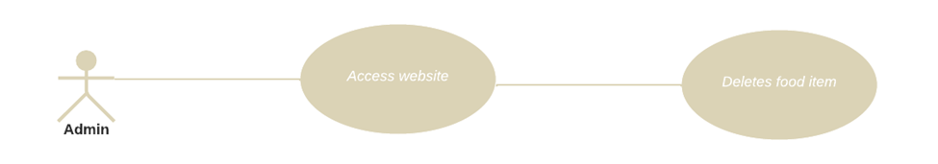

**Brief description:**

The admin chooses to delete a food item from the menu to make it accurate.

**Step-by-Step description:**

                 To begin this use case, the admin must be online and should be connected to the

                 restaurant's website to make changes in the restaurant's menu.

                1. The Admin accesses the website’s database.

                 2. The admin searches for the specific food item they want to delete.

                 3. Once the item is found, admin deletes it by selecting it and clicking on the

                     "Delete" option.

                 4. The Admin updates the database by saving the changes made.

                 5. The deleted food item has been successfully removed from the restaurant's menu.

1. Restaurant worker receives an order from a customer.

**Use Case: Receiving order from a customer**

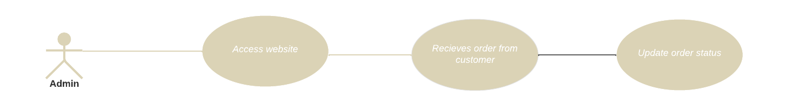

**Brief description:**

Admin access his website and accept the order placed by the customer and admin have to

update the order status.

**Step-by-Step description:**

1.Receive the order details from the customer.

2.Update the order status to "Received" in the admin system.

3.Prepare the order and track its progress.

4.Communicate any delays or issues with the customer.

5.Once ready, update the status to "Completed."

6.Notify the customer for pickup or delivery.

7.Close the order when the customer receives it.

1. Restaurant worker processes an order from a customer.

**Use Case : Admin processes an order**

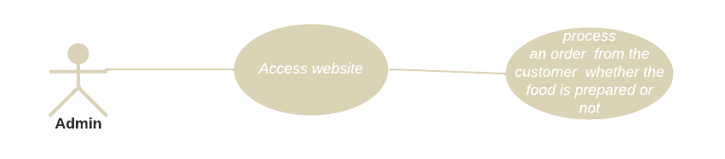

**Brief description:**

The admin can processes an order from the customer

**Step-by-Step description:**

To begin this use case, the admin must be online and should be connected to the

restaurant's website to update the status of the order.

1.Accepting the order placed by the customer.

2.Once the order is accepted the admin will update the status like “Your order has been accepted”.

3.The admin will review the order and update the status like “Pending”, “Processing”, “Out for Delivery", “delivered” or “Canceled”.

4.The customer may also receive notifications or updates regarding the status of change, depending on the restaurant’s notification system.

5.The admin will repeat the same process for any other orders that require status updates.

1. Restaurant worker manages reservations.

**Use Case: Restaurant worker manages reservations.**

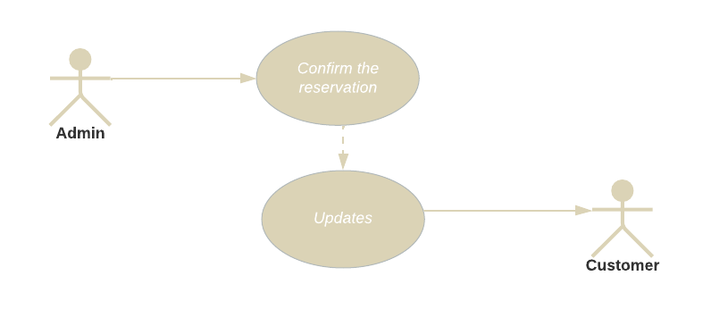

**Figure 8: Reservation Management (Admin Access).**

**Brief Description:**

The admin will manage a table reservation made by a customer and update it in the website's database. It is further confirmed to the customer.

**Initial step-by-step description:**

To initiate this use case, the Customer must be connected to the internet, logged in on the restaurant's webpage.

1. The Admin accesses the website’s database.

2. The Admin verifies the table

3. The Admin confirms the reservation

4. The Admin saves the changes made.

5. The website is updated according to the updates in the database

6. The website will send the confirmation to the customer.

1. **Design**

**4.1. ER diagram**

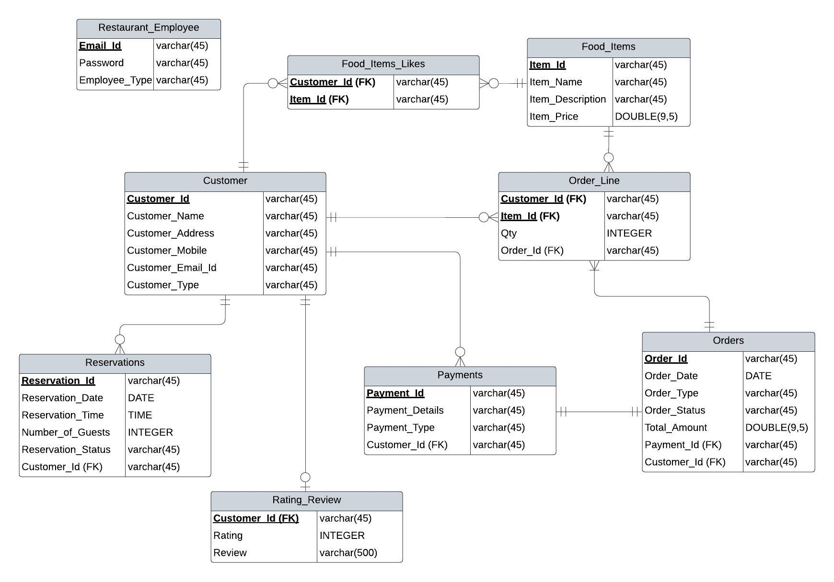

**Figure 9: ER diagram of restaurant website**

Description of the entities and their attributes in the Entity-Relationship Diagram (ERD):

1. Restaurant_Employee:
   * Email_Id: A unique identifier for the employee's email address.
   * Password: The password associated with the employee's account.
   * Employee_Type: The type or role of the employee within the restaurant.
2. Food_Items_Likes:
   * Customer_Id (FK): A foreign key referencing the Customer entity, representing the customer who likes the food item.
   * Item_Id (FK): A foreign key referencing the Food_Items entity, representing the food item that the customer likes.
3. Food_Items:
   * Item_Id: A unique identifier for the food item.
   * Item_Name: The name or title of the food item.
   * Item_Description: The description or details of the food item.
   * Item_Price: The price of the food item, represented as a decimal number.
4. Customer:
   * Customer_Id: A unique identifier for the customer.
   * Customer_Name: The name of the customer.
   * Customer_Address: The address of the customer.
   * Customer_Mobile: The mobile or contact number of the customer.
   * Customer_Email_Id: The email address of the customer.
   * Customer_Type: The type or category of the customer.
5. Order_Line:
   * Customer_Id (FK): A foreign key referencing the Customer entity, representing the customer who placed the order.
   * Item_Id (FK): A foreign key referencing the Food_Items entity, representing the food item in the order.
   * Qty: The quantity of the food item ordered.
   * Order_Id (FK): A foreign key referencing the Orders entity, representing the order to which the order line belongs.
6. Reservations:
   * Reservation_Id: A unique identifier for the reservation.
   * Reservation_Date: The date of the reservation.
   * Reservation_Time: The time of the reservation.
   * Number_of_Guests: The number of guests for the reservation.
   * Reservation_Status: The status of the reservation.
   * Customer_Id (FK): A foreign key referencing the Customer entity, representing the customer who made the reservation.
7. Payments:
   * Payment_Id: A unique identifier for the payment.
   * Payment_Details: Details or description of the payment.
   * Payment_Type: The type of payment.
   * Customer_Id (FK): A foreign key referencing the Customer entity, representing the customer who made the payment.
8. Orders:
   * Order_Id: A unique identifier for the order.
   * Order_Date: The date of the order.
   * Order_Type: The type of the order.
   * Order_Status: The status of the order.
   * Total_Amount: The total amount of the order.
   * Payment_Id (FK): A foreign key referencing the Payments entity, representing the payment associated with the order.
   * Customer_Id (FK): A foreign key referencing the Customer entity, representing the customer who placed the order.
9. Rating_Review:
   * Customer_Id (FK): A foreign key referencing the Customer entity, representing the customer who provided the rating and review.
   * Rating: The rating given by the customer.
   * Review: The review or feedback provided by the customer, with a maximum length of 500 characters.

Note: FK stands for "foreign key," which is used to establish relationships between entities in a database.

**4.2 GUI:** The updated web page images which are present in the prototype section serves as a demo for GUI as well.

1. **Analysis Models**

5.1. Data Flow Diagram

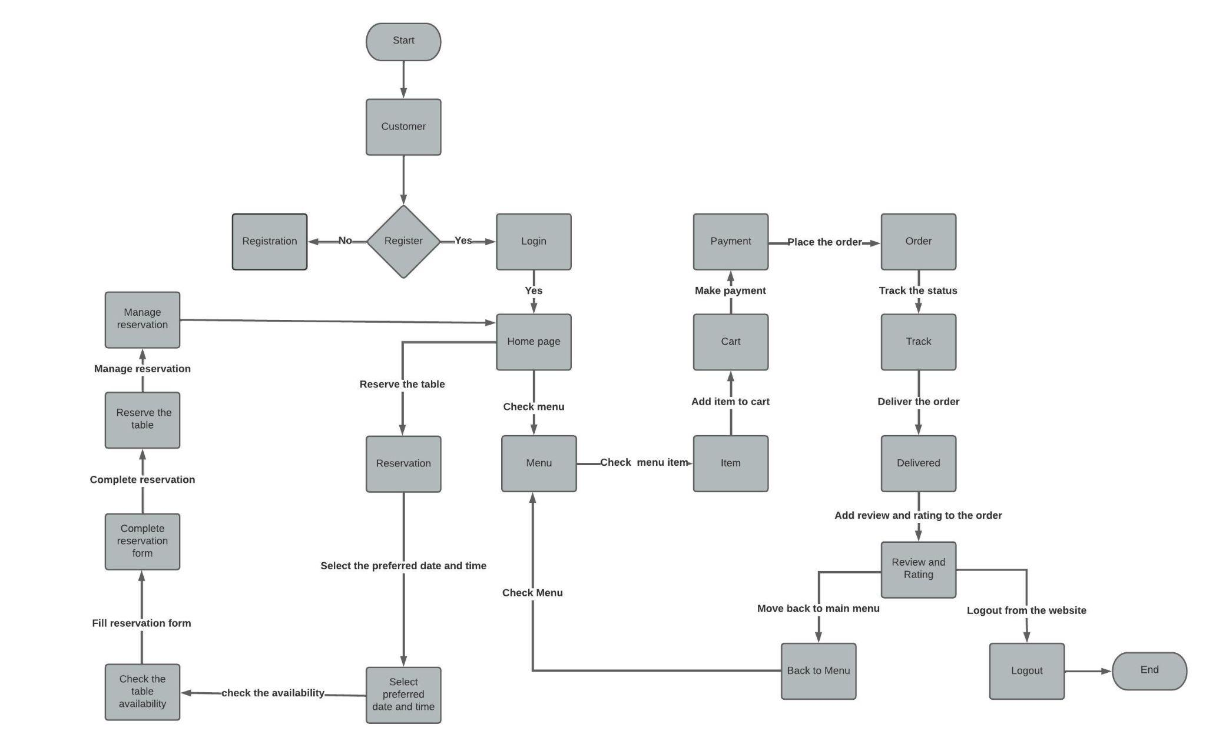

**Figure : Data flow diagram for customer.**

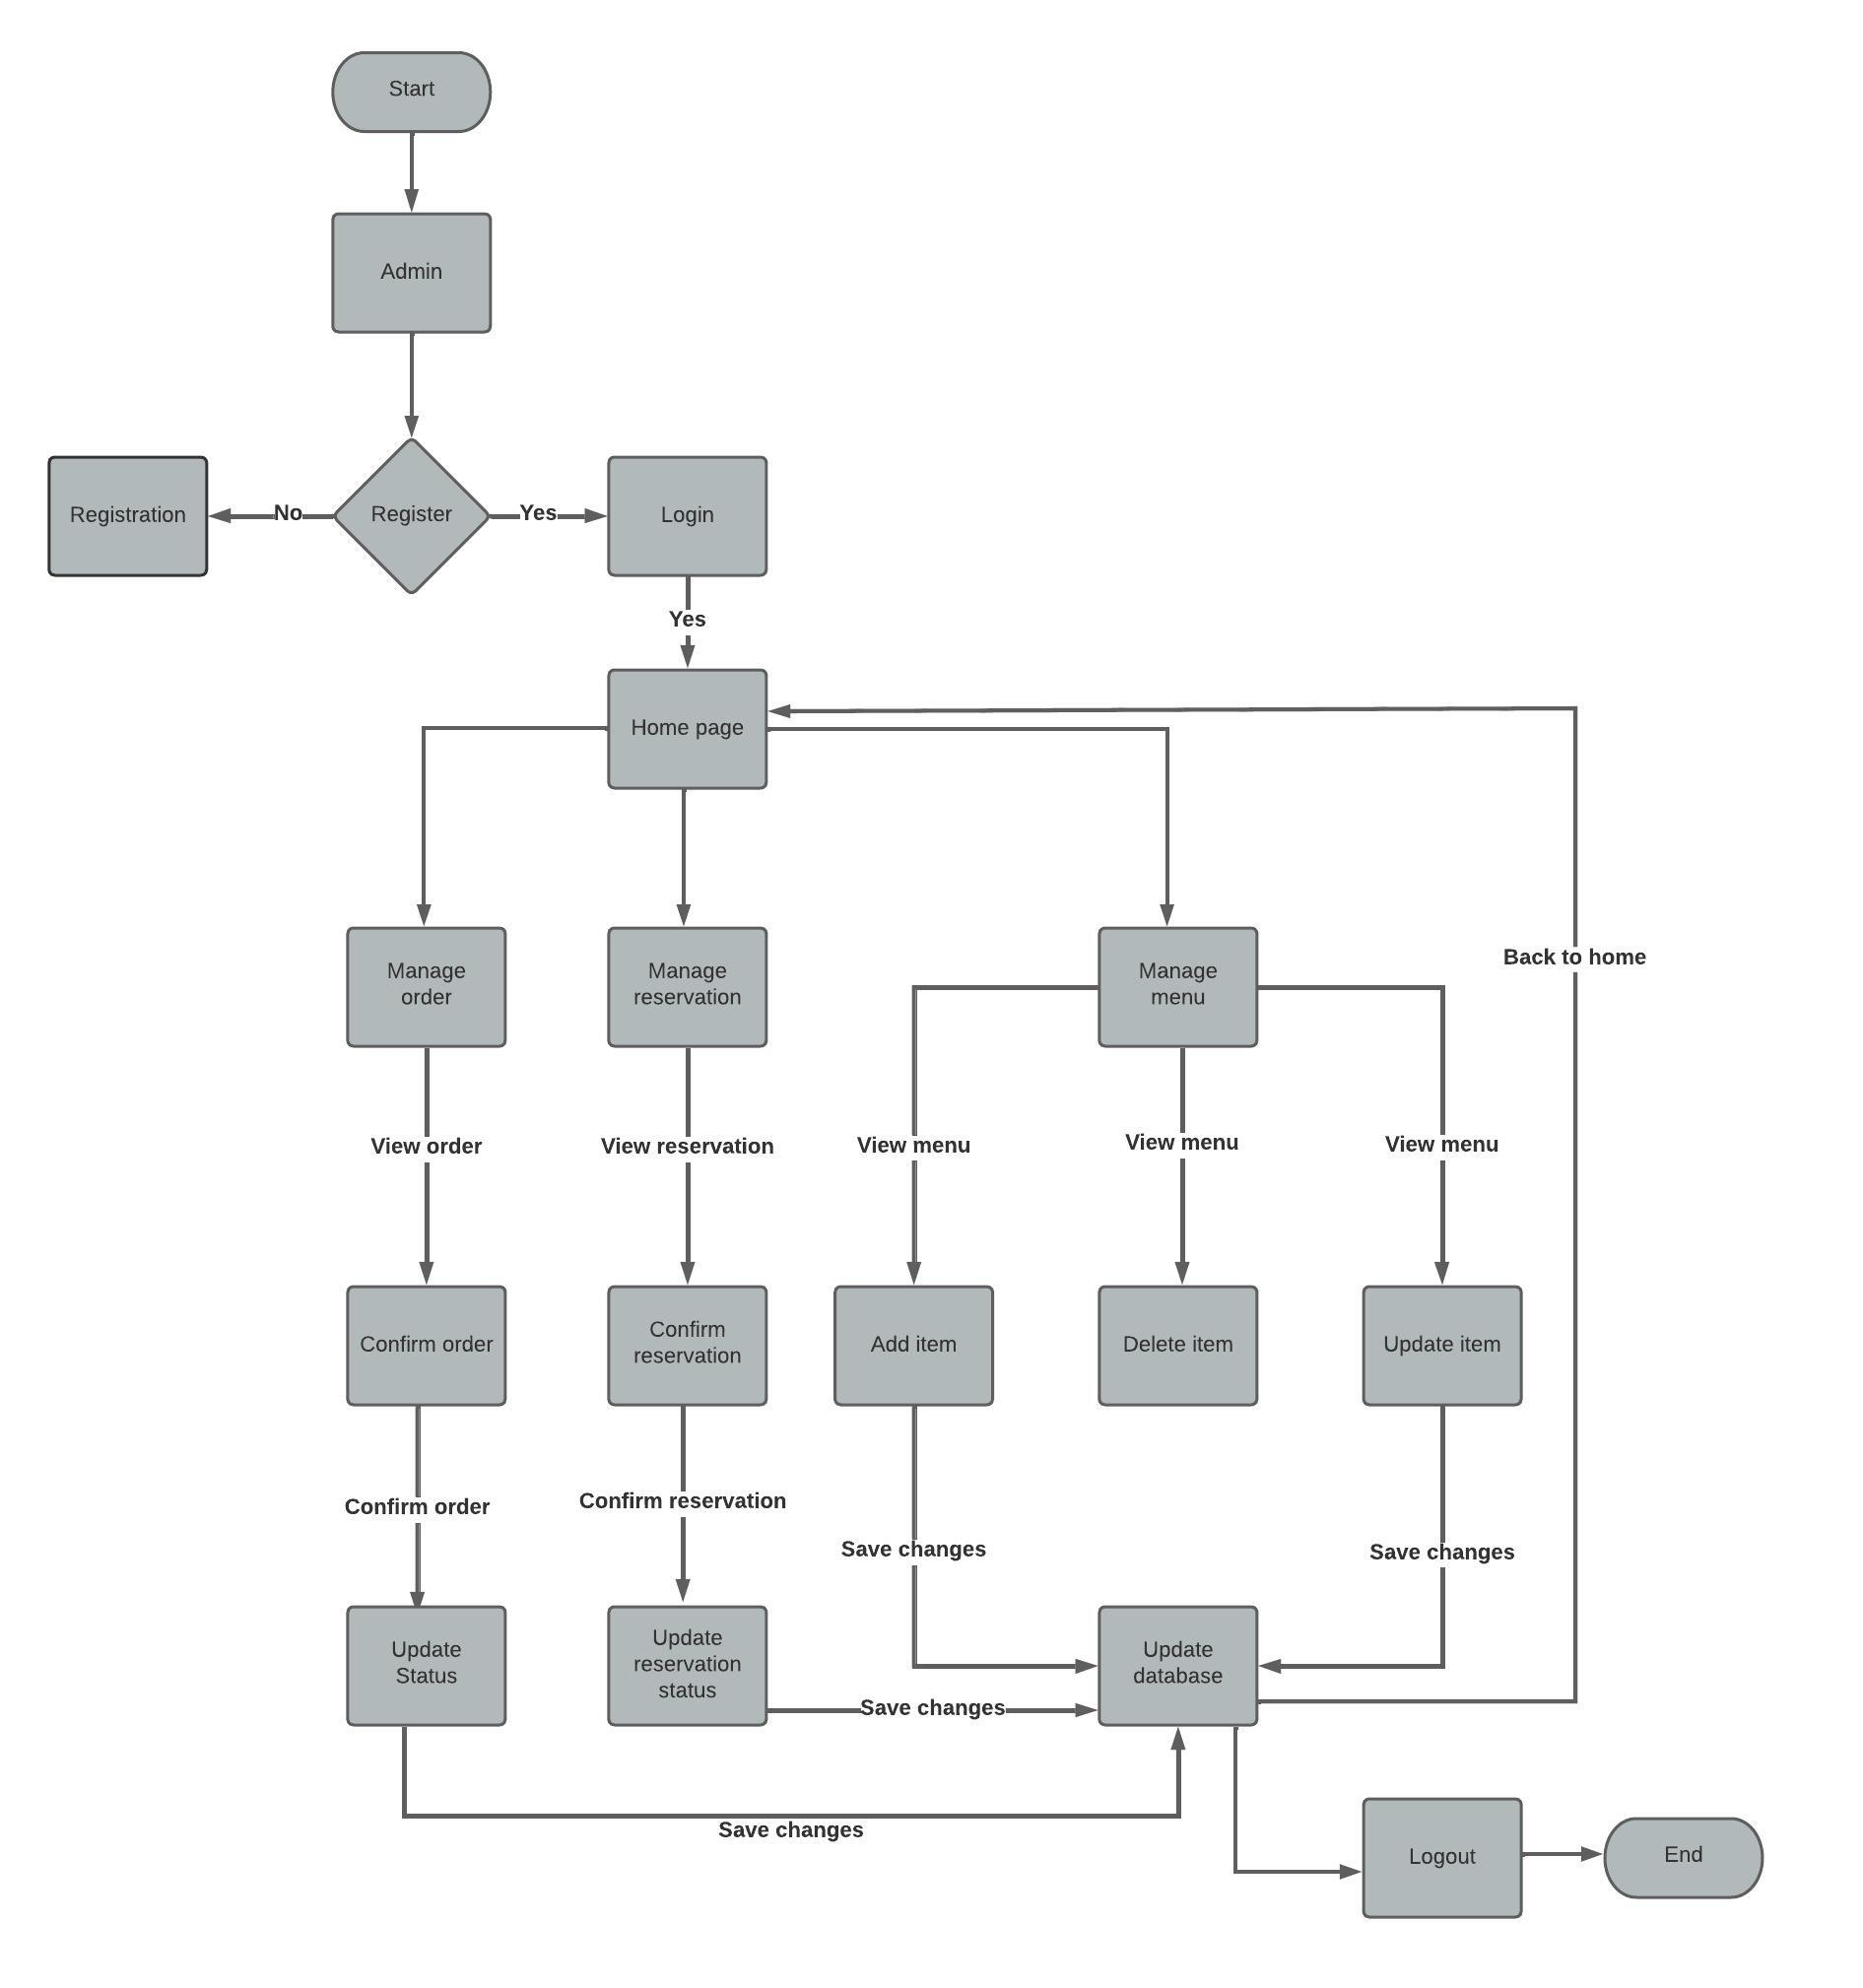

**Figure : Data flow diagram for admin.**

5.2. Sequence Diagram

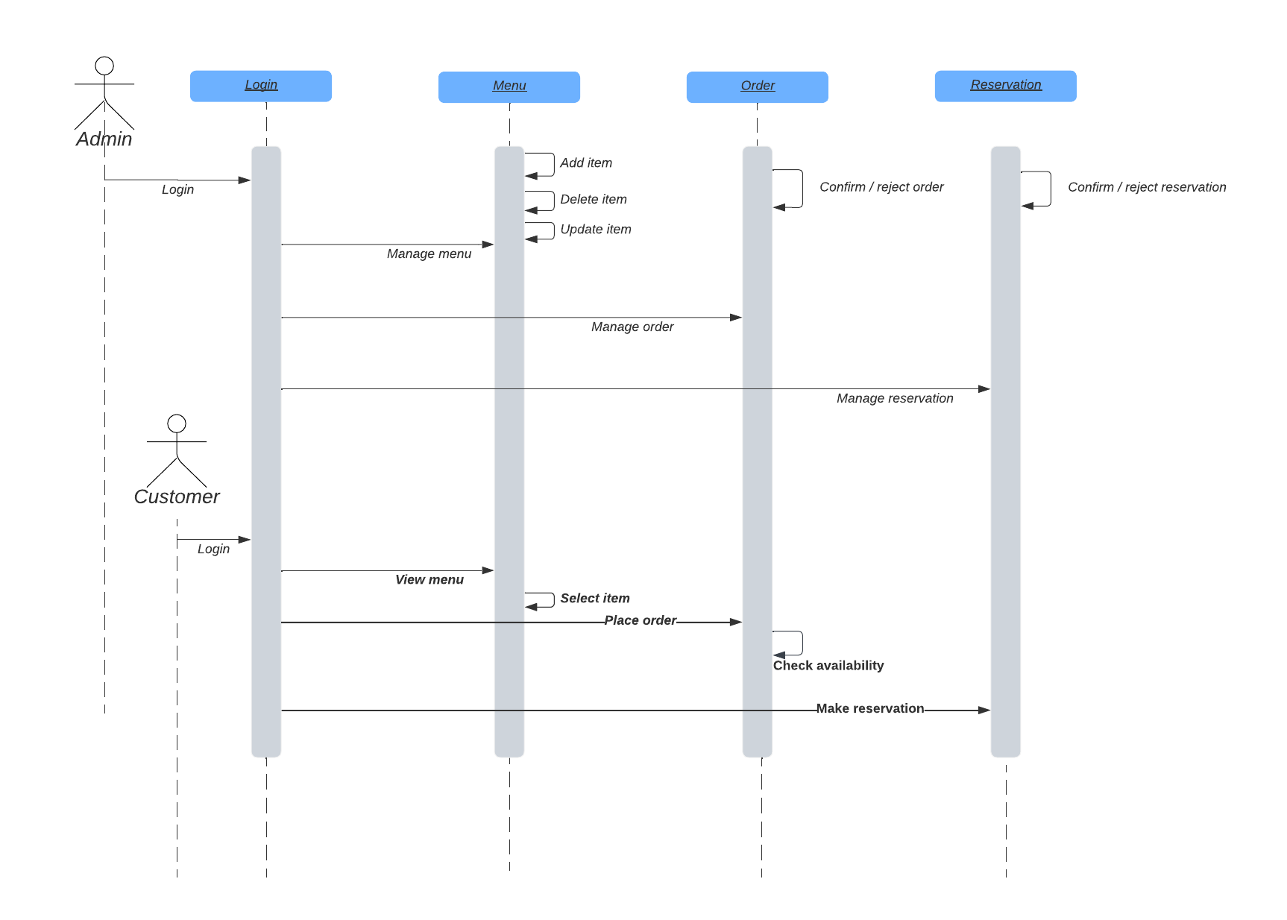

**Figure :** Sequence diagram of restaurant website.